IRAN: YOUNG MEN AT RISK OF EXECUTION
CRIMES TOOK PLACE WHEN CHILDREN
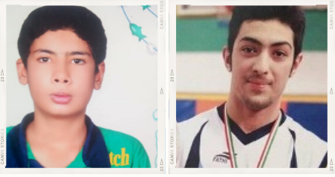
Hossein Shahbazi, now aged 20, is facing the death penalty for a crime that took place when he was 17 years old.
Iran ratified the Convention on the Rights of the Child in 1994 and the International Covenant on Civil and Political Rights in 1975.
The Convention on the Rights of the Child provides in Article 37 that ‘Neither capital punishment nor life imprisonment without possibility of release shall be imposed for offences committed by persons below eighteen years of age’.
The International Covenant on Civil and Political Rights provides in Article 6 that ‘Sentence of death shall not be imposed for crimes committed by persons below eighteen years of age’.
However, Iran continues to use the death penalty for crimes committed by people under the age of 18, in violation of its obligation under international law.
The authorities executed at least three people who were under 18 at the time of the alleged crime in 2020, and scores of others remain on death row.
In 2020 Iran carried out at least 246 executions, making it the country with the second highest number of executions last year.

After his arrest he was denied access to a lawyer or his family and underwent interrogation for 11 days at a detention facility run by the Iranian police. His conviction last year was based on ‘confessions’ that he says were obtained through torture and other ill-treatment during detention.
His execution was previously scheduled for 1 March 2021, 28 June 2021 and for 25 July 2021, despite a pending request for retrial. Execution was postponed following mounting international pressure.
Arman Abdolali, now aged 25, is also at risk of imminent execution for a crime that took place when he was 17 years old. His conviction relied on ‘confessions’ that he says were obtained when he was held in solitary confinement for 76 days and repeatedly beaten. The Courts claimed that because the crime took place 7 years ago it was not possible to determine Arman’s maturity at the time, and therefore assumes ‘full criminal responsibility’.
We are calling on the Iranian authorities to halt their executions, ensure convictions are quashed, and that any retrials are fair and comply with principles of juvenile justice. We are also calling for the Iranian authorities to take immediate steps to completely abolish the use of the death penalty against child offenders, in line with Iran’s obligations under international law, including the Convention on the Rights of the Child.

TAKE ACTION:
Take Action online by sending an email to the Iranian Embassy in the UK here: https://www.amnesty.org.uk/actions/help-stop-imminent-execution-two-young-men.

