stockport
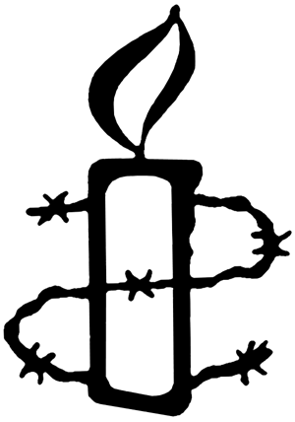
AmnestyApril 2024
Do One Thing: Free Saudi Arabia’s voices of change
Saudi Arabia’s authorities have adopted a zero-tolerance approach to anything they perceive as criticism. People are being sentenced to some of the harshest terms Amnesty International has ever documented in Saudi Arabia for exercising the right to freedom of expression, including decades-long prison terms, travel bans, and the death penalty.
- Saudi Arabia’s authorities have forcibly disappeared 29-year-old fitness instructor Manahel al-Otaibi since November last year. She has spent more than a year behind bars. And for what? Tweeting in support of women’s rights.
- Human rights defender Mohammed al-Qahtani remains imprisoned for his human rights work, despite finishing his 10-year prison sentence last year.
- Retired schoolteacher Mohammad bin Nasser al-Ghamdi was sentenced to death for criticizing the authorities on X, formerly Twitter, to a combined follower count of just 10 people.
- Salma al-Shehab, a PhD student and mother of two, is serving a 27-year prison sentence followed by a 27-year travel ban for social media posts in support of women’s rights.
- Abdulrahman al-Sadhan, a Red Crescent aid worker, is currently forcibly disappeared, and he has been imprisoned since March 2018. He was sentenced to 20 years in prison to be followed by a 20-year travel ban over his satirical tweets.
While this level of flagrant repression is taking place in Saudi Arabia, Crown Prince Mohammad bin Salman is spending billions of dollars in a remarkable display of smoke and mirrors, to polish the country’s image and hide the truth.
Act now and call on Saudi Arabia’s authorities to release all those wrongfully detained for exercising their freedom of expression. Sign the petition here.

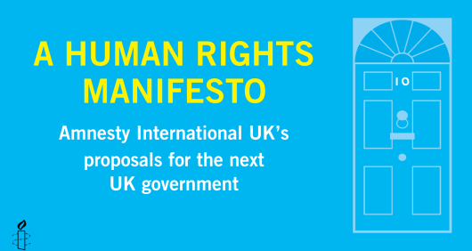
Human Rights Manifesto
Ahead of the anticipated General Election in the UK, AIUK have published a new
Human Rights Manifesto, outlining Amnesty’s demands for human rights-based approaches in both foreign and home affairs. You can access all the documents here.

FOR YOUR DIARY
We will be holding stalls in June:
Stockport Pride Sunday 2nd June 11am - 4pm
Cale Green Summer Fair Sunday 30th June 12 - 4pm

Please get in touch if you can support us with these events
EMAIL amnestystockport@gmail.com

Silent vigils for Palestine and Israel

Amnesty International, Manchester invites you to join us in our weekly silent vigil calling for a ceasefire and the protection of all civilians in Palestine and Israel.

Ever FRIDAY 5pm – 6pm St Peters Square, Manchester
Meet from 4.50pm in front of Central Library
Please wear black or dark colours (and please dress warmly!)
No placards / No banners / No flags / No chants

Simple placards will be provided bearing the messages, we will also provide tealights
Passersby will have the opportunity to leave a message of support

Please join us

