stockport
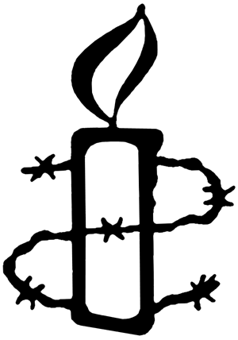
AmnestyMay 2024
Do One Thing:

Call on the Colombian government to reform the National Police and protect the rights of protesters in Colombia.
On 28 April 2021, thousands of people took to the streets in various Colombian cities to demand their rights. Women, young people, human rights defenders and LGBTIQ+ people led the protests with courage and determination, seeking a better future.
Instead of listening to them, the Colombian state, through its security forces, used less lethal weapons to deprive young people partially or totally of their sight, the damage to their eyesight is something they will live with for the rest of their lives. Officials also took advantage of the situation when dispersing demonstrations; as women and LGBTIQ+ people in the crowd were fleeing and trying to protect themselves from tear gas and gunfire, they molested them, insulted them and raped them. This cannot happen again. There must be comprehensive reform of the police! No one’s body should be abused , tortured or attacked to silence the demands of those wanting a better country!
Please send a message to the Colombian government and demand that it move forward with police reform in a participatory and inclusive way so that people can raise their voices without fear and with rights!

STALL AT CHEADLE HULME MAKER’S MARKET

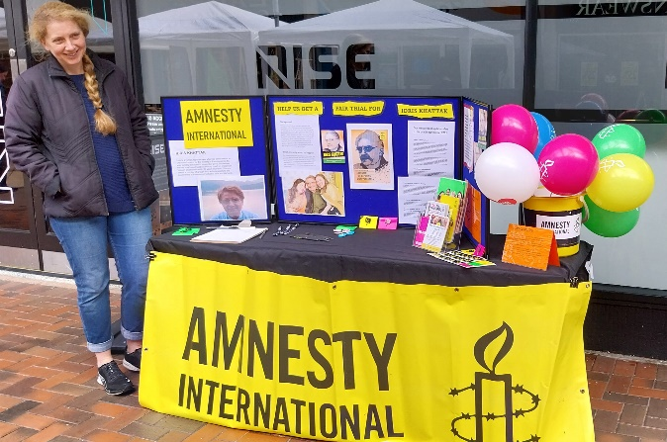
In May we experimented with a traditional stall and petitions at Cheadle Hulme Maker’s Market and a roller derby session in Urmston. The stall in Cheadle Hulme was helped by the lovely spring weather and we had a very positive response and some good conversations with shoppers.

FOR YOUR DIARY
We will be holding stalls in June:
Stockport Pride Sunday 2nd June 11am - 4pm
Cale Green Summer Fair Sunday 30th June 12 - 4pm

Please get in touch if you can support us with these events

Silent vigils for Palestine and Israel

Amnesty International, Manchester invites you to join us in our weekly silent vigil calling for a ceasefire and the protection of all civilians in Palestine and Israel.

Ever FRIDAY 5pm – 6pm St Peters Square, Manchester
Meet from 4.50pm in front of Central Library
Please wear black or dark colours (and please dress warmly!)
No placards / No banners / No flags / No chants

Simple placards will be provided bearing the messages, we will also provide tealights
Passersby will have the opportunity to leave a message of support

Please join us

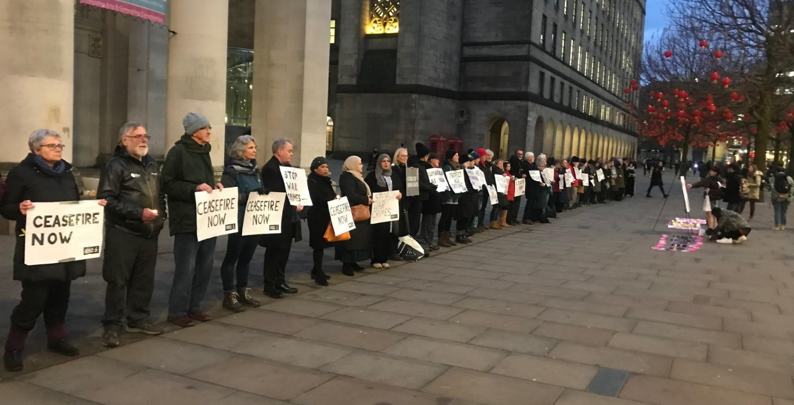

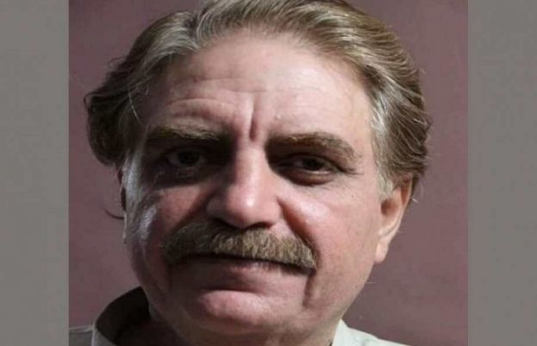
IDRIS KHATTAK Our Individual at Risk
Idris is a human rights worker who has been held at an unknown location by the military in Pakistan since he was forcibly abducted in November 2019. We believe he has now been tried by a military court on charges of treason and sentenced to 14 years in prison. We are one of a number of groups who write regularly to the government in Pakistan on behalf of Idris and his family.
Please write (email) to the following addresses using the sample letter below or your own words:
Prime Minister Shehbaz Sharif
Prime Minister’s Office
Constitution Avenue G-5/2
Islamabad
Pakistan
info@pmo.gov.pk
H.E. Mohammed Faisal
Pakistan High Commissioner in London
34-36 Lowndes Square,
London,
SW1X 9JN
phclondon@phclondon.org

Your Excellency Prime Minister,
I am writing to express my deep concern about Muhammad Idris Khattak who forcibly disappeared on 13 November 2019. I understand Idris Khattak has been sentenced by a military court to 14 years imprisonment for allegedly passing on official secrets to foreign agents. ​
The UN Human Rights Office of the High Commissioner has described Mr. Khattak’s reported sentencing as "an attack against the human rights community in Pakistan". As a civilian, he should be tried by a civilian court.​
I call on you to ensure the full restoration of Mr. Khattak's human rights, including unrestricted access to lawyers, a full medical assessment, his right to a civilian trial in full compliance with due process and his right not to be detained arbitrarily.

PANUSAYA SITHIJTRAWATTANAKUL (RUNG)
Rung – which means “rainbow” in Thai – became politically active while studying sociology and anthropology at university in the capital, Bangkok. She bravely took part in protests for social and political change throughout 2020. By August, she had become a protest leader. Watched by thousands, Rung called for equality, freedom of expression and – what is a highly sensitive topic in Thailand – the reform of the monarchy. Accused of provoking unrest, she was arrested in March 2020 under a lèse-majesté law that outlaws criticism of the monarchy. She was imprisoned for 60 days during which she was diagnosed with Covid-19. The authorities denied her bail six times. In defiance, she went on a 38-day hunger strike and was released on 30 April 2021. Rung faces dozens of charges against her and, if found guilty, life imprisonment. “Once you step into the prison; you will no longer feel that your humanity is still intact,” she says.
Please send this message to the following emails:
prforeign@gmail.com prforeign@prd.go.th rtelondon@thaiembassyuk.org.uk
Prime Minister Srettha Thavisin, Office of the Prime Minister, Pitsanulok Road, Bangkok 10300, Thailand
Dear Prime Minister
I call upon you to immediately drop all the criminal proceedings against Panusaya (Rung) Sithijirawattanakul and others charged solely for peacefully exercising their rights to freedom of peaceful assembly and expression.
I look forward to your government stating that they will comply with my request.

FUNDRAISING
Amnesty International is entirely independent and funded mainly by subscription and fundraising.

- We have applied for a bucket collection at a local supermarket in July/August
- We are Planning a stall at a car boot sale in August 2024.
If you are able to help with these events or with donations of goods please drop us an email to amnestystockport@gmail.com

