**AMNESTY UK KENT NETWORK NEWSLETTER: MAY 2024**

**HIGHLIGHTS**

This month you can

* **Join our speaker meeting on 21 May** to hear about Amnesty’s plans to campaign on **Economic, Social and Cultural Rights in the UK.**
* **Support** our work to strengthen links with **local MPs**
* **Join** us at the **Hastings Sanctuary Festival** on 23 June and the **Dover Multicultural Festival** on 29 June
* **Register** to attend (online or in person) **Amnesty UK’s AGM** on 22 June
* **Sign** the petition to the UK government to **scrap anti-protest laws**
* **Sign** the petition calling on **Meta** to take responsibility for its impact on **Rohingya communities**
* **Urge** the UK government to do more to protect **UK citizens arbitrarily detained abroad**
* **Attend** the play, **May 35th**, showing in Southwark from 29 May to 1 June
* **Read** Amnesty’s new report on the **targeting of Chinese students** in the UK
* **Join** events in Parliament Square to remember those killed in **Tiananmen Square** (2 June) and to call for the **closure of the Guantanamo** detention centre (5 June)
* **Join** the new AI network monitoring the actions of **UN Security Council** permanent members’ use of their vetoes to block efforts to counter **mass atrocities**

**SPEAKER MEETING: ECONOMIC, SOCIAL AND CULTURAL RIGHTS**

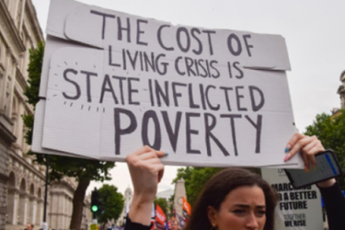

**Join us on 21 May at 7:30pm** to hear **Laura Trevelyan**, Amnesty UK’s Campaign Manager for Economic, Social and Cultural Rights, talk about Amnesty’s new plans to campaign on these rights in the UK, particularly the right to **adequate housing, food and healthcare in the UK**. **Please email me for a link to the meeting**.

**END ISRAELI APARTHEID**

We had a very successful day at **St Leonard’s street market** on 4 May where we highlighted the call to **End Israeli Apartheid** and collected **signatures for a message to the Prime Minister** to press for a **ceasefire in Israel / Gaza** and **suspend UK arms sales to Israel**.  More people signed up to our Network and we received over £50 in unsolicited donations.

On 17 May, our Tunbridge Wells team joined the local branch of the Palestine Solidarity Campaign for a screening of the film ‘1948: Creation & Catastrophe’ with a stall promoting Amnesty’s campaign work.

**CONTACT WITH MPs AND THE PREVENT CAMPAIGN**

Our members continue to develop links with **local MPs**, mainly to raise Amnesty’s concerns about the government’s **Prevent** programme. On 17 May, the Local Group in **Maidstone** had their latest meeting with **Helen Grant MP** when they raised concerns about the UK government’s approach to the Gaza conflict and its crackdowns on the right to protest, as well as Prevent. On 3 May, our Tunbridge Wells team met **Greg Clark** again, this time to discuss Prevent. Through our other local teams, we have also reached most other local MPs to raise our concerns about Prevent.

**If you would like to support our efforts to strengthen links with your own MP, and are not already involved, please get in touch.**

**OUR PROGRAMME IN 2024**

I attach an **updated programme of events** for the next 12 months. Over the next couple of months, we would **particularly welcome any support that you can offer** at our stalls at the **Hastings Sanctuary Festival** on **23 June** and the **Dover Multicultural Festival** on **29 June**. For the former, please email [amnestyhastingsrye@gmail.com](mailto:amnestyhastingsrye@gmail.com) and for the latter [sarakilian95@gmail.com](mailto:sarakilian95@gmail.com).

**RWANDA BILL**

**Credit: Marie-Anne Photography**

Despite widespread opposition, late into the night on 22 April, [**Parliament passed the Rwanda Act**](https://www.bbc.co.uk/news/uk-politics-68840441). This new law aggressively strips away the fundamental rights of those seeking safety on our shores. Amnesty has described it as a **deliberate act of cruelty and a national disgrace and will continue to challenge this act of injustice.** Amnesty’s statement in response to the Bill passing is [here](https://www.amnesty.org.uk/press-releases/uk-passing-rwanda-bill-national-disgrace?utm_content=147871&utm_campaign=MCFR1281S_LG_MM_April_24&utm_medium=email&utm_source=amnestyuk). Amnesty have also produced a video with Freedom from Torture and Liberty [here](https://twitter.com/AmnestyUK/status/1782711497040253228) and you can read a blog by Amnesty UK’s Refugee and Migrant Rights Programme Director [here](https://www.amnesty.org.uk/act-parliament-plumbs-new-lows?utm_content=147871&utm_campaign=MCFR1281S_LG_MM_April_24&utm_medium=email&utm_source=amnestyuk).

**Our Network will continue to campaign for refugee rights at various events during the summer, including at the Hastings Sanctuary Festival and the Dover Multicultural Festival. Why not join us at one of these?**

**AMNESTY UK 2024 ANNUAL GENERAL MEETING**

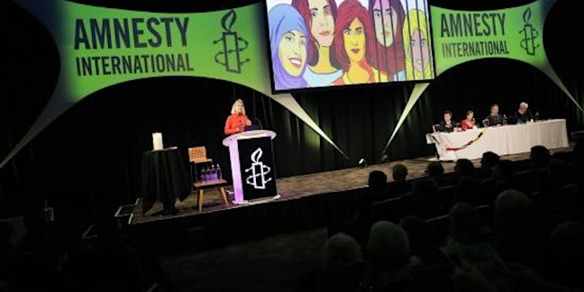

[**Amnesty UK’s AGM will take place at Sheffield Hallam University and online on 22 June**.](https://www.amnesty.org.uk/annual-general-meeting?utm_content=147871&utm_campaign=MCFR1281S_LG_MM_April_24&utm_medium=email&utm_source=amnestyuk) You can [book here](https://www.eventbrite.co.uk/e/amnesty-international-uk-agm-2024-registration-876744796287?aff=oddtdtcreator). Apart from AGM business, this is an opportunity to learn more about Amnesty’s work and plans, listen to inspiring speakers and to network. By voting on the AGM resolutions, you can also **help shape our movement’s future** as we seek to build an even more powerful human rights movement in the UK. Tickets include event entry, refreshments, lunch and an optional evening get-together with entertainment and food. For further information

AGM business can be attended by Amnesty International UK Section members only but the rest of the event is open to all. If you need to check your membership status, please contact [sct@amnesty.org.uk](mailto:sct@amnesty.org.uk).

**RIGHT TO PROTEST**

**The UK government’s crackdown on our freedom of expression** has been relentless, calculated and intentional as it seeks to reduce the public’s ability to hold them to account. Government ministers have been scapegoating communities - including by stoking up Islamophobia through harmful dog whistle rhetoric - all in an effort to crackdown on our freedom of expression.

As hundreds of thousands continue to march for a permanent ceasefire by all parties in Gaza, politicians and government ministers ramped up [their anti-protest rhetoric](https://www.amnesty.org.uk/blogs/campaigns-blog/theres-no-better-time-ceasefire-protest-armistice-day?utm_content=148101&utm_campaign=MEMA5553S_ACT_PTP_POAanniversary_5May&utm_medium=email&utm_source=amnestyuk). The government has proposed further anti-protest measures in the Criminal Justice Bill, while ramping up its racist Prevent programme and [expanding the definition of extremism](https://www.amnesty.org.uk/press-releases/uk-governments-extremism-definition-smash-and-grab-our-human-rights?utm_content=148101&utm_campaign=MEMA5553S_ACT_PTP_POAanniversary_5May&utm_medium=email&utm_source=amnestyuk). This takes us all further down the road toward authoritarianism, but it is impacting Muslim communities hardest.

On 3 May, Amnesty activists went to Parliament to expose the UK government’s “road to repression”. [**Please sign the petition to scrap anti-protest laws.**](https://www.amnesty.org.uk/actions/scrap-new-anti-protest-laws?utm_content=148101&utm_campaign=MEMA5553S_ACT_PTP_POAanniversary_5May&utm_medium=email&utm_source=amnestyuk#client_id=1317924&guid=3099a1df59384d75)

**ROHINGYA REFUGEES**

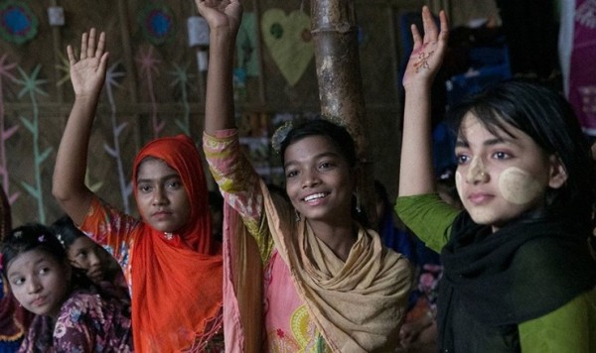

**Nick Clegg Action as part of the Maung Sawyeddollah and the Rohingya Refugee Children Case**

In 2017, almost one million Rohingya refugees were forced into Bangladesh from Myanmar following wide scale persecution, human rights violations, extrajudicial killings, summary executions, arson of Rohingya villages and schools, and other atrocities.  Leading up to the 2017 atrocities, Facebook became an echo chamber of virulent anti-Rohingya content. Meta, Facebook’s owners, was warned repeatedly about this, but failed to take meaningful action.

The Rohingya community are calling on Meta to provide US$1 million as part of a remedy to help fund educational projects for refugee children – a drop in the ocean to Meta, but a life changing intervention to hundreds of thousands of children. Amnesty is calling on Meta to take responsibility for enabling and allowing hatred and discrimination against Rohingya people to thrive on the Facebook platform and take action to help the affected Rohingya communities. [**You can sign the petition here**](https://www.amnesty.org.uk/activist-actions/Meta-remedies?utm_content=147871&utm_campaign=MCFR1281S_LG_MM_April_24&utm_medium=email&utm_source=amnestyuk)**.**

**PROTECTING UK NATIONALS ARBITRARILY DETAINED ABROAD**

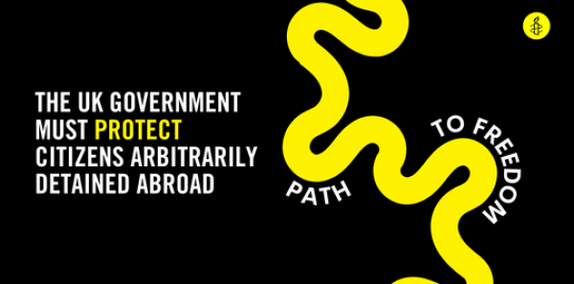

Amnesty has accused the UK government of **failing to take urgent action to protect UK citizens arbitrarily detained abroad**, arguing that the government’s inconsistent approach to these cases reveals the absence of a coherent strategy to support such individuals or deal effectively with their situation. [Please sign this petition urging the Prime Minister to act](https://www.amnesty.org.uk/actions/protect-uk-nationals-arbitrarily-detained-abroad?utm_content=147871&utm_campaign=MCFR1281S_LG_MM_April_24&utm_medium=email&utm_source=amnestyuk).

**CHINA**

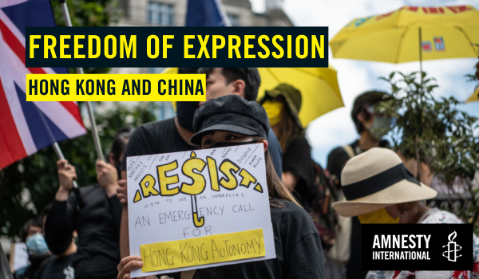

**May 35th** is an award-winning play that opened to sold out theatres in Japan and Taiwan. The global premiere of the English translation **will be staged in Southwark Playhouse Elephant from 29 May to 1 June**. There will be a post-show discussion with guests after selected performances. [You can book tickets to the play here.](https://southwarkplayhouse.co.uk/productions/may-35th/)

May 35th is the secret code of the 4 June 1989 **suppression of the Tiananmen Square protests**, a date the Chinese censors wished to wipe from history. Based on interviews and real-life stories of parents who lost their children, the play is a moving story about an elderly couple’s dying wish to hold a proper ritual for their son in the same place where he was murdered by the state 35 years ago. The play was staged in Hong Kong in the past but is impossible to stage the show there again after the enactment of the National Security Law in 2020 by the Chinese government.

**The crackdown on freedom of expression by Chinese and Hong Kong authorities continues.** Students, activists and whole communities are targeted. Now, Chinese and Hong Kong authorities are targeting anyone who dares to speak out, even if they’re based in the UK. [Amnesty’s new report](https://www.amnesty.org.uk/press-releases/uk-chinese-and-hong-kong-students-uk-live-fear-long-arm-chinese-government?utm_content=148663&utm_campaign=MEMA5564T_UPT_NR_HongKongFoE_13May&utm_medium=email&utm_source=amnestyuk) focuses on students targeted in the UK and 7 more countries, calling on the **UK government to recognise that transnational repression is a threat to human rights**; and on **UK universities to protect their students and staff from transnational repression**.

On **2 June from 2pm to 5pm**, Amnesty members and others will **gather at Parliament Square** in London to remember those who died during the massive protests in Beijing and to demonstrate solidarity with human rights defenders imprisoned for speaking up against human rights violations by the authorities.

**ACTION AGAINST MASS ATROCITIES**

A **new network** has been set up by Amnesty UK activists to monitor the actions of the five permanent members of the UN Security Council **with a view to taking action whenever they use their vetoes to obstruct action against mass atrocities**, for example the US veto of the resolution of 20 February on a ceasefire in Gaza. The network held a webinar ‘How can we stop states obstructing attempts by the UN to end mass atrocities?' on 24 April with a panel of excellent speakers. You can watch the recording [**here**](https://email.amnestyuk.org.uk/c/12eAjfQiU8dTOmP8RbGVTceImfpd) using this passcode **p4hc3zZ&.**  To get involved, email Janet Phillips at [janetpphi@gmail.com](mailto:janetpphi@gmail.com).

**RIP JACKIE EDWARDS**

We were very sad to learn **that Jackie Edwards passed away on 11 April**. Jackie was a loyal and consciousness member of Amnesty for many years and an active supporter of both the Canterbury Group and the Kent Network. We shall miss her. There will be a wake on Friday 24 May from 1pm at the Bell in Shepherdswell.



**(Please see the attachment for a full list of our planned activities)**

20 May at 9:00 am: Defend Julian Assange, Royal Courts of Justice, London WC2A 2LL. In-person.

21 May at 7:30pm: Kent Network speaker meeting: Laura Trevelyan, Amnesty UK’s Campaign Manager for Economic, Social and Cultural Rights. Email [graham.minter@amnesty.org.uk](mailto:graham.minter@amnesty.org.uk) for a link.

29 May to 1 June: May 35th play at Southwark Playhouse Elephant**.** [Book here](https://southwarkplayhouse.co.uk/productions/may-35th/)

2 June at 2:00pm to 5:00pm: Remember Tiananmen Square gathering at Parliament Square, London.

3 June at 7:30pm: Maidstone, Medway and Swale Group meeting at Maidstone Community Support Centre, 39-48 Marsham St, Maidstone ME14 1HH. Email [mmands.amnestygroup@gmail.com](mailto:mmands.amnestygroup@gmail.com).

5 June at 1:00pm to 3:00pm: Close Guantanamo Vigil at Parliament Square, London. Email [maclixby@gmail.com](mailto:maclixby@gmail.com).

17 - 23 June: Refugee Week

22 June, 9.30 am - 7:30 pm - Amnesty International UK Annual General Meeting, Sheffield Hallam University. In-person and online options. [Book here](https://www.eventbrite.co.uk/e/amnesty-international-uk-agm-2024-registration-876744796287?aff=oddtdtcreator).

23 June: Hastings Sanctuary Festival stall. Email [amnestyhastingsrye@gmail.com](mailto:amnestyhastingsrye@gmail.com).

29 June: Dover Multicultural Festival stall. Email [sarakilian75@gmail.com](mailto:sarakilian75@gmail.com).

All the best

Graham