**AMNESTY UK KENT NETWORK NEWSLETTER: JULY 2024**

**HIGHLIGHTS**

**A huge welcome** to the 20 Amnesty members and supporters who have joined our Network in the last month, bringing our total membership to 187. Below you will find a range of ways in which you can get involved, but **please don’t hesitate to get in touch if you want to get involved in other ways too**.

Lots of good news this month, with the release of **Julian Assange**, **Toomaj Salehi** and **Rita Karasartova**, three successful **Kent Network events**, and the welcome and long-awaited appointment of two new **Amnesty South-East Activism Reps**.

This month you can

* **join us online on Tuesday** to hear about the latest developments in the **Close Guantanamo** campaign
* **support us** at our next two public events in **Tunbridge Wells** and **Folkestone**
* **call on your local MP** to commit to defending human rights in the UK and nationally
* **call on the new Prime Minister** to live up to his promise to centre human rights in everything his government does
* **join the Amnesty Feminists Network**

**CLOSE GUANTANAMO**

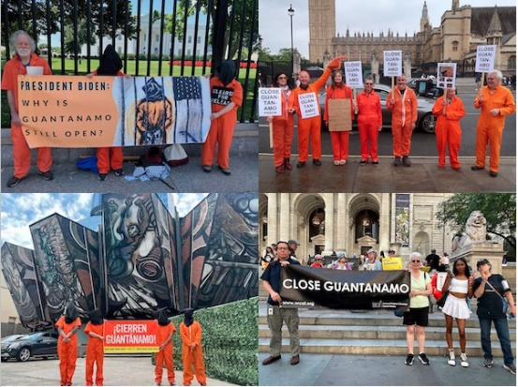

**Join us this Tuesday 16 June at 7:30pm** to hear **Andy Worthington** talk about the campaign to close Guantanamo Bay Prison. Andy is an investigative journalist, author, campaigner, commentator and public speaker. Recognized as an authority on Guantánamo and the “war on terror”, he is co-founder of the [Close Guantánamo Campaign](https://www.andyworthington.co.uk/2024/07/07/photos-and-report-the-ten-coordinated-global-vigils-for-the-closure-of-guantanamo-on-july-3-2024/). Please email [mark@markclixby1.plus.com](mailto:mark@markclixby1.plus.com) to request a link.

**MORE UPCOMING NETWORK EVENTS: HELP NEEDED**

We shall have stalls at two more local events in the next month. On 21 July, we shall be at the **Tunbridge Wells MELA** and on 27 July, we shall be at **Folkestone Pride**. If you are free to help at either event (or both!), please email [dominique.oneil@outlook.com](mailto:dominique.oneil@outlook.com) for the first and [maclixby@gmail.com](mailto:maclixby@gmail.com) for the second.

**WHAT HAVE WE BEEN DOING?**

Hastings Sanctuary Festival

Dover Multicultural Festival

Chatham Carnival

At three separate events in the last month, we have raised local awareness of human rights issues and Amnesty’s local profile, secured signatures for letters to newly elected MPs and to Keil Starmer, and signed new members to the Kent Network.

In our **letters to the new MPs** (for Hastings and Rye and Chatham and Aylesford), we drew their intention to **Amnesty’s manifesto** (see below) and called on them to **commit to defending human rights in the UK and nationally.**

In our **two letters to the new Prime Minister**, we called on his government to ensure that the UK’s **immigration system** respects the UK’s international obligations and promotes equality, justice and human dignity; and to call for an **immediate permanent ceasefire** by all parties to the conflict in **Gaza** and a **ban on the sale of arms** and military equipment and technologies.

**GENERAL ELECTION**

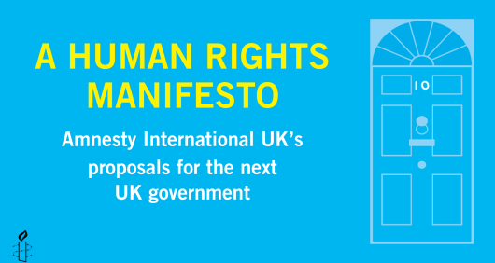

**Thank you** to all those who signed letters to the parliamentary candidates in their constituencies calling on them to pledge support for [**Amnesty UK’s Human Rights Manifesto**](https://www.amnesty.org.uk/files/2024-06/AIUK%20manifesto%20full%20June%202024%20final.pdf?VersionId=J3LMsuzmE96OuPmg_uBgk1hlN2ysNzxN). We now aim to approach all the successful candidates calling on them as MPs (whether or not they replied to our earlier communications) to use their new roles to defend human rights in the UK and nationally.

With so many new MPs, this is an important time to start to build strong links with them. To this end, we are again writing to one of our Network members in each constituency in our area asking them, if they have not already done so, to **coordinate an approach to their local MPs.** **If you want to get involved and have not yet been invited to do so, please email me.**

[Here](https://www.amnesty.org.uk/actions/act-now-call-new-pm-protect-human-rights), you can also **call on the Prime Minister** to live up to his promise to centre human rights in everything his government does.

**JULIAN ASSANGE**

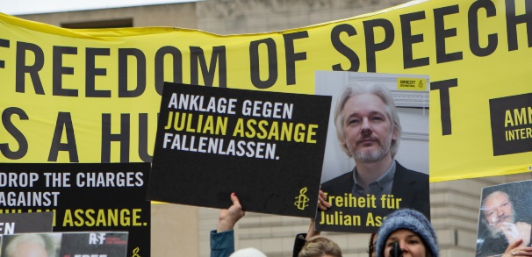

**Good news!** Julian Assange has finally been released from UK state custody after [five years of imprisonment](https://www.amnesty.org/en/latest/news/2024/04/julian-assanges-five-year-imprisonment-uk-unacceptable/). Amnesty’s Secretary General said: “We firmly believe that **Julian Assange should never have been imprisoned in the first place** and have continuously called for charges to be dropped. The years-long global spectacle of the US authorities hell-bent on violating press freedom and freedom of expression by making an example of Assange for exposing alleged war crimes committed by the USA has undoubtedly done historic damage.”

**IRAN: TOOMAJ SALEHI**

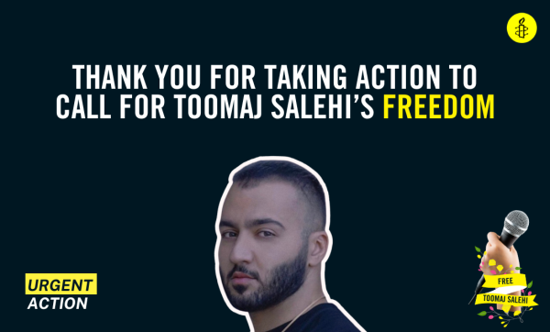

**Good news!** Last month, we encouraged you to call for a stop to the execution of the Iranian rapper and hip-hop artist, **Toomaj Salehi**. This month, we can report that **his death sentence has been overturned**. Toomaj remains in prison and Amnesty continues to call on the Iranian authorities to release him immediately.  Many thanks to all who responded to our call for action.

**KYRGYZSTAN: RITA KARASARTOVA**

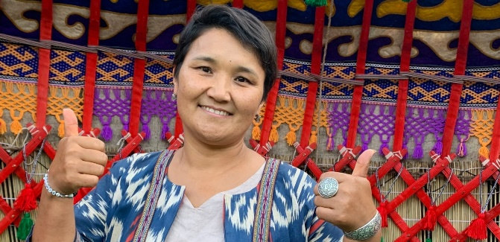

**More good news!** In Write for Rights 2023, many of you will have called for the dropping of charges against **Rita Karasartova**. The charges against her and her co-defendants were politically motivated and based on groundless allegations that they were plotting mass riots. **Rita and her co-defendants have been acquitted**. This is an important victory for justice and human rights and has highlighted ongoing issues with fair trials and the suppression of the right to freedom of expression in Kyrgyzstan. After receiving the news, Rita told Amnesty: “We didn’t expect it at all. We were crying from surprise”.

**AMNESTY FEMINISTS**

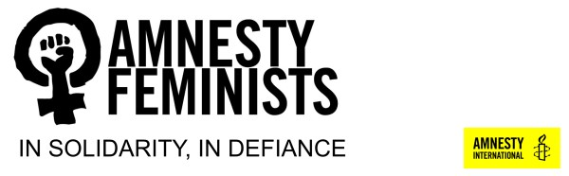

It’s good to see that Amnesty Feminists have become more active of late. They campaign for **women’s rights** in the UK and around the world. They attended the most recent **protest for Gaza** as an Amnesty Feminist bloc and their next campaign will focus on **women’s rights in Afghanistan**. To join their mailing list, email [amnestyfeminists@email.amnestyuk.org.uk](mailto:amnestyfeminists@email.amnestyuk.org.uk).

**NEW SOUTH EAST ACTIVISM REPS**

We are very pleased to report the appointment of two new **South East Activism Reps**, working in a job share. **Arianna Pisetti** is a member of the Guildford Group and is leading an initiative to build a Surrey and Borders Network on similar lines to our Kent one. She is also a regular participant is our monthly speaker meetings. **Sara Kilian** is a member of our Kent Network Core Team and already leads our work in the Dover and Folkestone area.

Activism Reps provide important support, advice and encouragement to local activists in their region and we look forward to working closely with them.



**Tuesday 16 July at 7:30pm to 8:30pm: Kent Network speaker meeting with Andy Worthington of the Close Guantanamo Campaign. Email** [**markclixby@gmail.com**](mailto:markclixby@gmail.com) **for a link.**

**Sunday 21 July: stall at Tunbridge Wells MELA at Calverley Grounds, Tunbridge Wells. Email** [**dominique.oneil@outlook.com**](mailto:dominique.oneil@outlook.com) **for details.**

**Saturday 27 July: stall at Folkestone Pride at The Leas, Folkestone. Email** [**maclixby@gmail.com**](mailto:maclixby@gmail.com) **for details.**

**Wednesday 7 August at 1pm: Close Guantanamo Vigil in London. Email**[**maclixby@gmail.com**](mailto:maclixby@gmail.com)**for details.**

**(Please see the attachment for a full list of our planned activities)**

All the best

Graham