**NAMCAR (North America and the Caribbean)**

**Canada, Cuba, Dominican Republic, English Speaking Caribbean, Haiti, USA**

**Amnesty International reminds President-elect Trump and all elected officials across the country today of their obligations to respect, protect and fulfil human rights in their policies and approaches, here at home and around the world. Amnesty International has documented extensively the damage to human rights caused by President-elect Trump’s first administration, including its efforts to redefine human rights, and stands ready to defend human rights in his second Presidential term.**

Lise

AIUK Country Coordinator, Caribbean States excluding Cuba: vacant

AIUK Country Coordinator, Cuba: vacant

[Lise.Rossi@amnesty.org.uk](http://Lise.Rossi@amnesty.org.uk)

AIUK Country Coordinator, USA & Canada

@AIUKNAMCAR:  [Facebook](https://en-gb.facebook.com/AIUKNAMCAR/)

**Contents**

|  |  |  |  |
| --- | --- | --- | --- |
| **Country** | **Topic** | **Action** | **Page** |
| Intro & Contents |  |  | 1 |
| Canada | Wet’suwet’en Indigenous Land Defenders | XX | 2-3 |
|  | Canada must Protect Indigenous Women, Girls and 2SLGBTQQIA+ People | XX | 3 |
| Cuba | Urgent Action: Pedro Albert Sanchez | X | 4-5 |
| Haiti | Various Newspaper articles: Al Jazeera, the Guardian and AP |  | 5 |
| Trinidad & Tobago | No report |  | 5 |
| USA | US Elections | Press Release | 5-6 |
|  | Defending Abortion rights | XX | 6-7 |
|  | Death Penalty: Richard Moore | Action closed | 7 |
|  | Death Penalty: Freddie Eugene Owens | Action closed | 7 |
|  | Guantánamo Detention Centre | **Very Urgent Action** + vigil | 8-9 |
|  | **Exhibition of Guantánamo Art** | X | 9 |
|  | **Very Urgent Action**: Leonard Peltier | XX | 10 |

*\* Some of the actions are genuinely ongoing so there is some repetition in the Newsletter. But please keep writing. It also provides a background for new Amnesty Members.*

**CANADA**

**Wet’suwet’en Indigenous Land Defenders**

|  |  |  |
| --- | --- | --- |
|  |  | **This case is included in the W4R campaign this year.**  Sabina Dennis stands her ground as police dismantle the barricade to enforce the injunction filed by Coastal Gaslink pipeline at the Gidimt’en checkpoint near Houston, British Columbia, on 7 January. Photograph: Amber Bracken |

**DEFENDING ANCESTRAL LANDS AGAINST PIPELINES**

**For over a decade, the Wet’suwet’en Nation land defenders have exercised their rights to protect their territory in British Columbia from harmful projects**.

Despite their opposition on human rights and environmental grounds, construction of a 416- mile gas pipeline began in their territory in 2019 without their consent, leading to legal and physical confrontations. If completed, the pipeline would divide the territory into two. During Royal Canadian Mounted Police (RCMP) raids on Wet’suwet’en territory, land defenders and their supporters were arbitrarily detained for peacefully defending their land against the construction of the pipeline and exercising their Indigenous rights and their right to peaceful assembly. In 2023 and 2024, several land defenders went on trial, including Sleydo’ (Molly Wickham), Shaylynn Sampson and Corey (Jayochee) Jocko, who were found guilty of criminal contempt. However, the trio filed abuse of process applications arguing their human rights were violated during their arrests and detention. The British Columbia Supreme Court started hearing their applications this summer**.**

**First-ever Amnesty Prisoner of Conscience in Canada**

|  |  |  |
| --- | --- | --- |
| **Amnesty International has made the unprecedented decision to designate Likhts’amisyu Clan Wing Chief Dsta’hyl of the Wet’suwet’en Nation as the first-ever designated Amnesty International prisoner of conscience in Canada**…. |  | Starting on September 3, a court in Smithers, B.C. began hearing arguments related to abuse-of-process complaints filed by three land defenders who were arrested during a violent police raid on Wet’suwet’en territory in November 2021. The individuals involved are Sleydo’ (Molly Wickham), a Wing Chief of the Cas Yikh house of the Gidimt’en Clan of the Wet’suwet’en Nation; Shaylynn Sampson, a Gitxsan woman with Wet’suwet’en family ties; and Corey “Jayohcee” Jocko, a Kanien’kehá (Mohawk) from Akwesasne.  A delegation with representatives from Amnesty International Canada, Amnesty International Germany and Front Line Defenders attended the hearings. |

**PLEASE continue to TAKE ACTION**

**Write to the Canadian High Commmissioner in London**, Ralph Goodale, Canada House, Trafalgar Square, London, SW1Y 5BJ,

**Also write to the Attorney General , Niki Sharma**

2135 East Hastings Street, Vancouver, BC, Canada, British Columbia.

**Canada must Protect Indigenous Women, Girls and 2SLGBTQQIA+ People**

Indigenous women, girls and 2SLGBTQQIA+ currently face the highest rates of femicide in Canada. They make up 16 per cent of all femicide victims, 11 per cent of all missing women and are six times more likely to go missing or be murdered than non-Indigenous women and girls.

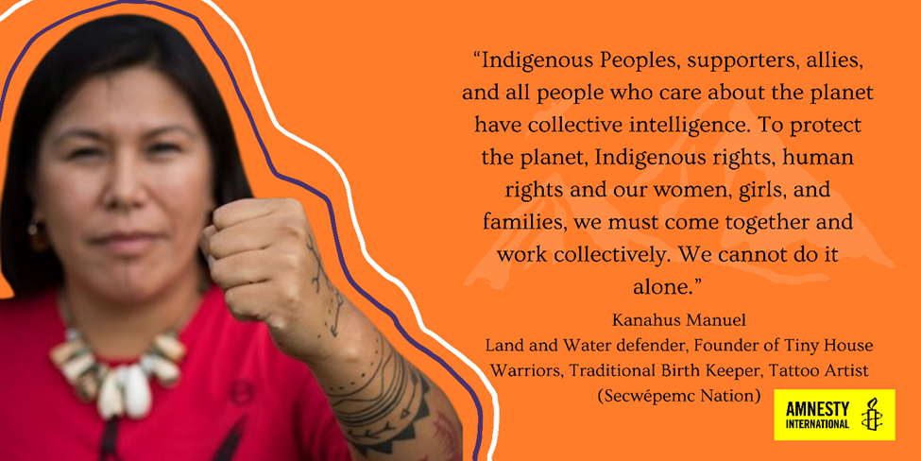

In 2019, the Final Report of the National Inquiry into Missing and Murdered Indigenous Women, Girls, and 2SLGBTQQIA+ People comprehensively highlighted the unique risks faced by Indigenous women, girls and 2SLGBTQQIAA+ people empowered by anti-Indigenous racism, sexual and gender-based violence and structural discrimination through colonial structures including residential schools, the Sixties Scoop, the Indian Act, mass incarceration, police brutality, transportation and social service inequities.

Lack of affordable and safe transportation services have significantly increased Indigenous women and girls’ exposure to violence, exploitation and structural discrimination. Transportation inequities are a leading cause of the high number of cases of missing and murdered Indigenous women and girls along the Highway 16, infamously known as the ‘Highway of Tears’.

**ACTION REQUEST**

Sign [our e-action](https://takeaction.amnesty.ca/page/131664/action/1?_ga=2.125801290.1138281217.1727099831-89649237.1716303740&_gac=1.128318974.1727100162.Cj0KCQjwo8S3BhDeARIsAFRmkOMkQ0t0jxNAEByEB2_VhdDZysOC7slFpL4nmKzWi2rJ6Wec6jGf5KEaApGJEALw_wcB) calling for the creation of a time-bound Indigenous-led National Action Plan Implementation Strategy that would outline how the Calls for Extractive and Development Industries in the Final Report of the National Inquiry into Missing and Murdered Indigenous Women and Girls, will be implemented.

**CUBA**

# Authorities must release those unjustly imprisoned and repeal repressive laws

An Urgent Action has been issued by Amnesty for **Pedro Albert Sánchez** (Here is the [full text](https://www.amnestyusa.org/urgent-actions/urgent-action-cuba-teacher-in-need-of-medical-care-cuba-60-24/)). Pedro Albert Sánchez, a 68-year-old teacher and human rights defender, has been arbitrarily detained in Cuba since November 22, 2023. Despite his critical health conditions, including cancer, Pedro is being denied adequate healthcare. He is a prisoner of conscience jailed simply for exercising his human rights to freedom of expression and of peaceful assembly. We urge the Cuban authorities to immediately and unconditionally release Pedro Albert Sánchez and ensure he urgently receives adequate healthcare.

**PLEASE TAKE ACTION AS SOON AS POSSIBLE UNTIL: January 8, 2025**

|  |  |  |
| --- | --- | --- |
|  |  | Here is the [link.](https://www.amnestyusa.org/urgent-actions/urgent-action-cuba-teacher-in-need-of-medical-care-cuba-60-24/) to the Urgent Action. |

Amnesty declares four new prisoners of conscience in midst of new wave of state repression. **Félix Navarro, Dama de Blanco Sayli Navarro, Roberto Pérez Fonseca and Luis Robles have been named as prisoners of conscience.**

[Here](https://www.amnesty.org.uk/press-releases/cuba-amnesty-declares-four-new-prisoners-conscience-midst-new-wave-state-repression) is the full Press Release.

Amnesty calls for the immediate and unconditional release of prisoners of conscience, and of all those unjustly imprisoned solely for exercising their human rights. The organisation also calls on the government of Miguel Díaz-Canel to respect human rights, including the right to freedom of expression, association and peaceful assembly, to repeal repressive legislation, and to end the repression of dissidents.

In December 2023, he was returned to prison after a court revoked his "limited freedom" sanction.

In June, his son reported that the island's regime is allowing his father to die by denying him access to medical care and medicines at the 1580 correctional facility in Havana. Professor Pedro Albert is serving a five-year sentence for his participation in the protests of July 11, 2021.

**CARIBBEAN STATES (EXCLUDING CUBA)**

**Haiti**

Here are several recent articles about the present situation in Haiti:

Al Jazeera: <https://www.aljazeera.com/where/haiti/>

The Guardian: [MSF aid workers ‘heartbroken’ as charity forced to halt services in Haitian capital after repeated attacks](https://www.theguardian.com/global-development/2024/nov/21/msf-aid-workers-heartbroken-as-charity-forced-to-halt-services-in-haitian-capital-after-repeated-attacks)

AP News: <https://apnews.com/hub/haiti>

**Trinidad and Tobago**

No report available.