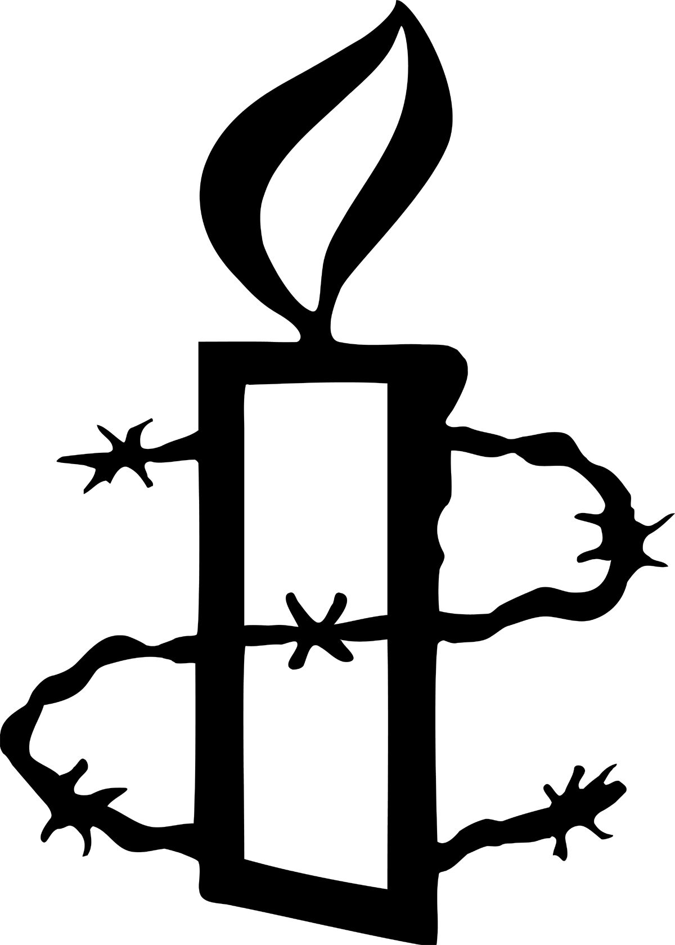
Amnesty International UK
SUPPLIER QUESTIONNAIRE

Business name
Address
Contact name details including phone number and email
Company registration number (if applicable)
Annual turnover
Number of employees
Nature of business
Countries the business operates in
What is the legal status of your business?
PLC |  |  | Partnership
Private company |  |  | Not for profit
Other (please state)
If your business is a company which is part of a group, please give details of any parent or subsidiary companies:

Nature of business

Please describe the nature of your business, including details of goods produced and services provided.

Does your business or any business you are associated with manufacture or supply any products which have been implicated in human rights violations by military, security or police forces?
This would include equipment which may be used in relation to the death penalty or torture, small arms, products or services for weapons systems, as well as services for military, security, or police forces, such as provision of surveillance technology.

Has your business or any business you are associated with been involved in activities or been accused of involvement in any human rights violations, publicly or otherwise?
This would include any activities causing substantial damage to the environment, environment, drinking water, means of food production and/or the exposure of the population to harmful substances.

If the answer to the above question is yes, is your business doing anything to remedy this? Please give details.

What checks do you undertake to ensure that your business or any business you are associated with is not involved in any activities that would have an adverse impact on human rights?

Supply chain

Does your business have a Modern Slavery statement? If so please provide a copy or a link to where this is published.

Do you have any permanent establishments (including employing staff and/or manufacturing bases) in any of the following jurisdictions:

China Y/N
North Korea Y/N
DR Congo Y/N
Myanmar Y/N

Have you been made aware of any labour exploitation or abuse (e.g. hazardous work environments, forced labour, child labour or migrant labour) in any parts of your supply chain?

Do you have any policies, processes or checks to detect and prevent labour exploitation in your supply chain?

Does your business have any accreditations in relation to supply chain management e.g. Ethical Trading initiative?

Employees

Does the business recognise an employee union?

Does the business have any workers on zero hour contracts? If so, to what extent are these used (how many staff, % of workforce)

Do all of your employees earn the minimum wage, and all London based employees earn the London Living wage?

What is the businesses approach to Equality, Diversity and Inclusion?

Does the business have any accreditations in relation to good employment practices, e.g. Living Wage employer?

Does the business have any of the following policies in place:

- Staff code of conduct Y/N
- Dignity at work Y/N
- Maternity/paternity/adoption/shared parental leave Y/N
- Recruitment Y/N
- Fixed term contracts Y/N
- Sickness absence Y/N
- Grievance Y/N
- Redundancy Y/N

If no, is there an intention to put any of these policies in place in the future?

Please provide any other information or policies that you feel are relevant to our knowledge of your employment practices.

Environmental practices

Outline the business’ approach to measuring its direct and indirect environmental impact?

What is the business’ plan to reduce carbon emissions and/or to achieve a net zero position?

Does the business report on its carbon emissions (eg SECR) and if so where is this information published?

Does the business have an environmental policy or include any environmental initiatives as part of its business strategy?

Does your business participate in any external environmental initiatives e.g. Business Declares, SME Climate Hub?

Please provide any other information or policies that you feel are relevant to our knowledge of your environmental practices.

Legal and taxation

Does the business or associated businesses have a permanent establishment or registered office in a jurisdiction considered as a tax haven (defined as top 10 TJN tax haven index (https://cthi.taxjustice.net/en/)

If so, what is the business rationale for this?

Outline the business’ tax policy. How does the business ensure it pays its fair share of taxation in each jurisdiction it operates in?

