**NEXT GROUP MEETING – AGM Thurs 20th Feb**

**7-9pm venue to be confirmed. For more information email: benkin64@talktalk.net**

**MEETING PROBLEMS**

January brought us the bad news that Nora Street Community House has been closed by the council. Which means that our January meeting was held in Evelyn’s home. The council are encouraging us to use another community centre and are helping us to find one that suits our small group and is fairly near the town centre which would be more convenient for any new members.

Since our priorities are free, safe parking, reasonable charges and no change in our meeting day and times it will be quite difficult to find a suitable venue.

**THE RIGHT TO PROTEST**

37,686 called on the Home Secretary to scrap anti-protest laws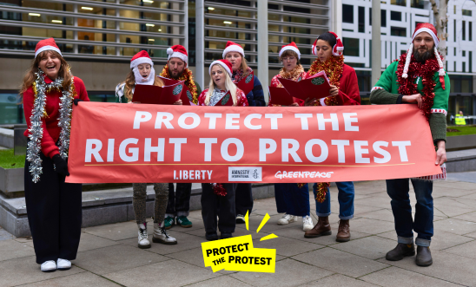

**On 11 December 2024 AIUK, Liberty & Greenpeace handed a 200,000 signature petition to the Home Secretary**

The world is grappling with inequality, discrimination and climate change.

**Protest is more essential than ever to challenge injustice**. To scrap anti-protest powers and halt the crackdown on the right to protest in England and Wales.

**GOOD NEWS**

With conflict and displacement happening globally, rising authoritarianism, unchecked corporate power and more, today is a worrying day for people across the world.  
Let’s remember that there are more of us - people who want a fair and equal society, who believe in the right to freedom, truth and dignity, than those who don’t.   
Even though it might not feel like it, human rights wins are happening all the time. In the last few weeks alone there have been some huge wins:

**DORGELESSE NGUESSAN HAS FINALLY BEEN RELEASED IN CAMAROON.**

[](imap://benkin64%40talktalk.net@imap.talktalk.net:143/fetch%3EUID%3E/INBOX%3E57025)After more than four years of wrongful imprisonment for peacefully exercising her human rights, Dorgelesse Nguessan has finally been released. In September 2020, Dorgelesse joined her first protest in Douala due to her growing concern about Cameroon’s economy. Charged with “insurrection” and “public demonstrations” among other charges, she was then sentenced to five years in prison by a military court on December 7th 2021

**ANGOLA**

[](imap://benkin64%40talktalk.net@imap.talktalk.net:143/fetch%3EUID%3E/INBOX%3E57025)**TIKTOKE**R [**NETH NAHARA WAS FREED FROM PRISON**](https://email.amnestyuk.org.uk/c/1e0HDW9kCV6YbM48fu8p4g5PTvc) after 16 months behind bars.

Also released are Adolfo Campos, Gildo das Ruas, Tanaice Neutro and Pensador.

**CITIZENSHIP STRIPPING**

In the aftermath of the Second World War, citizenship deprivation fell almost entirely into disuse, in revulsion at the Nazis stripping the citizenship of Jewish citizens of Germany.

There was a widespread recognition that it was a racist policy that has no place in countries governed by the rule of law.

Yet in the UK in 2025 the Home Secretary holds an excessive power to strip citizenship. This power was used to strip more than 200 people of their British citizenship by the previous government over the last fourteen years. Those deprived include British mothers who are unlawfully detained with their children in prison camps in North East Syria. They have been abandoned by their government to face torture, disappearance and death. People who have dual nationality can be stripped of BRITISH CITIZENSHIP.

**Many other countries have taken back their citizens.**

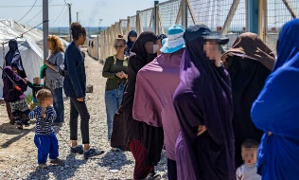Perhaps the case of Shamima Bagum should be considered again while we are also reconsidering the grooming of young females in the UK as she was only 15 years old when she was enticed abroad. Should we consider not allowing under 18s (perhaps lower!) to travel abroad without parental consent except in very special circumstances.

The case of Shamina Bagum who has been denied the right to a fair trial should be a cause of concern to us all.

The right to a fair trial is a most crucial part of our legal system and the appeal court has sought to uphold that principle. Everyone, without exception, deserves, and must be given, a fair trial.

As Liberty, a human rights NGO involved in the case, has [said](https://www.libertyhumanrights.org.uk/issue/right-to-a-fair-trial-upheld-after-liberty-legal-intervention/): “The right to a fair trial is not something the government can take away on a whim. It is a fundamental part of our justice system and equal access to justice must apply to everyone”. Her lawyers [added](https://www.bbc.co.uk/news/uk-53427197): “She has never had a fair opportunity to give her side of the story. She is not afraid of facing British justice, she welcomes it. But the stripping of her citizenship without a chance to clear her name is not justice, it is the opposite”.

This is clearly right. The government should not be allowed to revoke someone’s citizenship when they are not in the country and then refuse them permission to enter the country to fight that decision.

Amnesty International believes that the arbitrary removal of citizenship is a form of oppression and that it should not be used as a weapon of control. Amnesty International has spoken out against the removal of citizenship rights in the UK, India, and Bahrain.

Amnesty International has criticized the removal of Shamima Begum's UK citizenship, calling it a "medieval" punishment. Amnesty International believes that the UK should be helping its citizens who are stranded in dangerous circumstances, not barring their safe return.

The Court of Appeal (Baroness Carr LCJ, Bean and Whipple LJJ)

On 23 January the Court of Appeal handed down judgment in the appeal by Shamima Begum against the deprivation of her British citizenship. Amnesty International UK’s Refugee and Migrant Rights Director, said:

“Banishing citizens is a punishment from the medieval era and should have no place in the modern world. Shamima Begum was born a British citizen and had lived in the UK her entire life right up to the point she was lured to Syria when still a 15-year-old schoolgirl.

“ISIS have been responsible for appalling crimes in Syria, Iraq and elsewhere, but that doesn’t change the fact that Begum is British and was groomed and trafficked to Syria.

“The UK authorities should be responsible for all its citizens, including Shamima Begum, and should not be exiling them – so it’s very disappointing that the Court of Appeal has concluded it cannot overturn what the Home Secretary has done.

“The UK should be helping its citizens stranded in dangerous circumstances in Syria, not barring their safe return to the UK - whether or not there are grounds for them to face prosecution or other measures on their return.”