**NEXT GROUP MEETING 16th Jan 2025 15-17 Nora St. Community Rooms, Howley, WAI 2JG**



**Happy New Year to you all from the Warrington Amnesty Group! 2024 was a disastrous year for human rights. We must endeavour to bring about improvements in 2025.**

**WRITE 4 RIGHTS RELEASES**

**2021 to 2024**

**POWER OF THE PEN: SUCCESSES FROM PREVIOUS WRITE FOR RIGHTS CAMPAIGNS.**

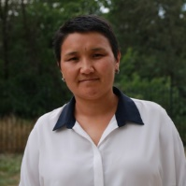 Human rights defender **RITA KARASARTOVA** was arrested in 2022 along with 26 others for opposing a new border agreement that gave control of a freshwater reservoir to Uzbekistan. She was initially detained for organising ‘mass disorder’ and later charged with attempting to ‘violently overthrow the Government’, which carries a potential 15-year sentence. Rita and at least 21 others were acquitted on 14 June this year: a significant victory for justice and human rights in Kyrgyzstan, even though the prosecutor has filed an appeal against the ruling. She subsequently expressed her gratitude for the countless letters she received from Amnesty supporters during the campaign, emphasising that each one gave her immense hope and strength, reinforcing her belief in the power of solidarity.

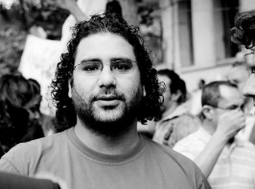

In 2021, Amnesty campaigned for Egyptian human rights lawyer **MOHAMED BAKER**, who received a presidential pardon in July last year and was released from prison the following day. He is now safely reunited with his loved ones.

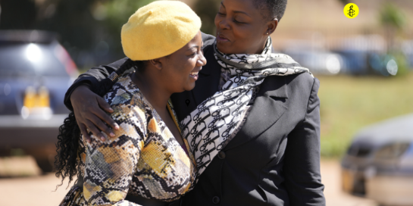

**CECILLIA CHIMBIRI AND JOANAH MAMOMBE** were acquitted by the Zimbabwean High Court in July 2023 of communicating falsehoods and obstructing the course of justice. The two – together with Netsai Marova, who did not face trial as she is out of the country – were arrested and abducted in May 2020 following a protest about the Government’s failure to provide social protection during the Covid 19 pandemic. Amnesty campaigned for them during the 2022 Write for Rights campaign.

**THE CITY OF HEBRON on the West Bank**

I was going to give a potted history of Hebron but it proved impossible – you could write a book and still not have covered everything. HEBRON is a city where the history of Jews and Palestinians intertwines to form a complex story that mirrors many of the current problems between the two races.

**HELPING 600 STRUGGLING FAMILIES**

[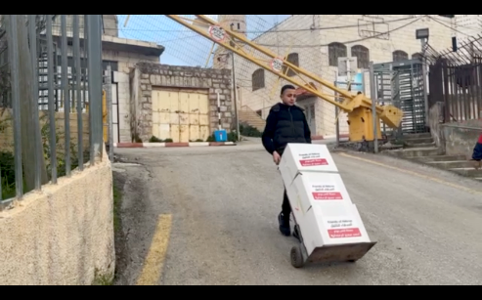](https://www.hebronfriends.org/friends_of_hebron_helps_nearly_600_struggling_families?e=eb45c02bc652a10d2e7adabc598a687a&utm_source=hebronfreedomfund&utm_medium=email&utm_campaign=end_of_year_2024_7&n=7)

Friends of Hebron provided aid to around 600 struggling families during a time of need. The genocidal war in Gaza resulted in severe economic devastation in Hebron, and families were going hungry. We fundraised to provide families with essential aid and our volunteers carried the boxes through the checkpoints directly to the families' doors.

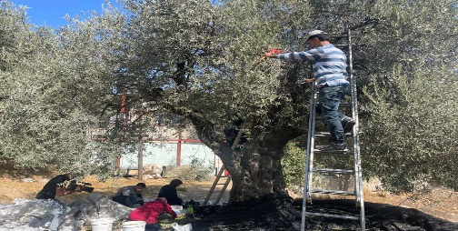**OLIVE HARVEST FOR PEACE**

We supported local families with our annual Olive Harvest campaign to support the ancient practice of the olive harvest. Our volunteers – Palestinian and international – showed up to protect families and help them harvest their olives, as well as harvest the olives for families living outside the restricted area, who were prevented by Israeli forces from entering their own land.

**WINNING THE RIGHT LIVELIHOOD AWARD**

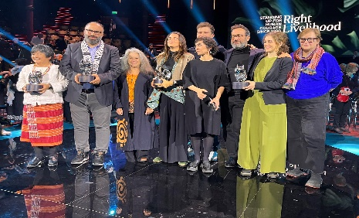

On December 4th, our Executive Director Issa Amro travelled to Stockholm, Sweden to accept the "alternative Nobel Prize" awarded to him and Youth Against Settlements, which is supported by Friends of Hebron as a sister organization. Meanwhile, Israeli settlers used Issa's absence **to attack his house in Hebron**, which was thankfully being watched by one of our other brave volunteers who could protect the house from being taken over.

**RECEIVING THE FRANCO-GERMAN HUMAN RIGHTS PRIZE**

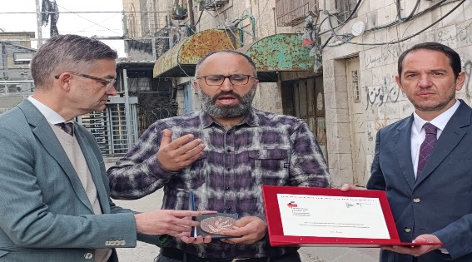

On December 10th, representatives from the French and German government presented Issa Amro with the Franco-German Prize for Human Rights Prize and Rule of Law. The Israeli military refused to let the German and French officials enter and reach Issa's home, and they were forced to give the award outside the checkpoint instead. International recognition **helps ensure the protection of activists** like Issa and others like him.

**SPEAKING TOURS AND WOMEN EMPOWERMENT**

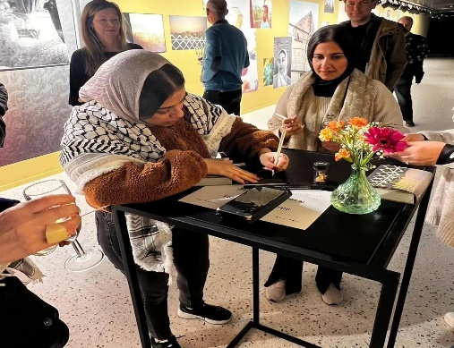

We have sent volunteers abroad to tell their stories. This includes the sisters Sundus and Aysha Azza who toured Belgium to tell their stories of growing up right next to fanatic Israeli settlers in Hebron and their work with Youth Against Settlements. They presented the 'Om project – a book about women in Hebron telling their own stories.