**AMNESTY UK KENT NETWORK NEWSLETTER: MARCH 2025**

**HIGHLIGHTS**

Welcome to our March newsletter. This month, you can

* **Learn and discuss** the work of the **International Criminal Court** at our online speaker meeting this Tuesday
* **Sign up** to **Amnesty Feminists** and support their work
* **Sign the petition** to stop the execution of **two Iranian women at imminent risk of execution**
* **Stay informed** of human rights developments in **Hong Kong**
* **Sign the petition** to **stop automated racism** in the UK
* **Follow developments** in the UK Court Case considering claims for damages for **Shell oil spills in Nigeria**
* **Keep up** with progress of the **UK government’s Crime and Policing bill** and its potential impact on the **right to protest**
* **Read Amnesty’s submission to the UN** about the **UK’s failure to meet its obligations** under the **International Covenant on Economic, Social and Cultural Rights**
* **Get ready** for **Amnesty UK’s National Conference and AGM** on **5-6 July**
* **Check out** our list of **forthcoming events**

**SPEAKER MEETING THIS TUESDAY: THE INTERNATIONAL CRIMINAL COURT (ICC)**

**President Putin** and **Prime Minister** **Netanyahu** are **fugitives** from international justice. **Ex-President Duterte** of The Philippines is in The Hague awaiting trial for crimes against humanity committed during his “war on drugs”. **President Trump** has announced sanctions against ICC officials and others supporting the Court’s work. **Join us online this Tuesday at 7:30pm** to hear about the work of the International Criminal Court, its origins and role, its successes and its challenges. **Email** [**arianna.pisetti@amnesty.org.uk**](mailto:arianna.pisetti@amnesty.org.uk) **for a link.**

**WHAT WE’VE BEEN DOING**

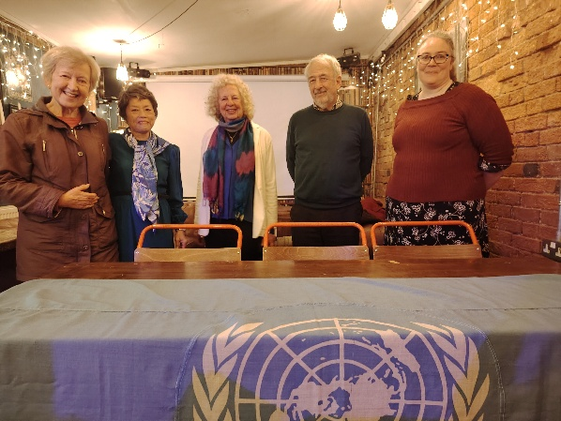

UNA event in Tunbridge Wells

On 5 March, we joined the Maidstone, Medway and Swale Group for the third in our series of roundtable conversations to raise awareness of the **human rights impact of the Prevent Duty**. On 6 March, we were part of a panel of speakers at an event organised by the Tunbridge Wells branch of the United Nations Association to discuss **war crimes and the International Criminal Court**. On 9 March, we had a stall at an event to celebrate **International Women’s Day** organised by the Tunbridge Wells branch of Soroptimist International, where we collected 32 signatures for the **campaign in support of Afghan women**.

**FEMINIST NETWORK**

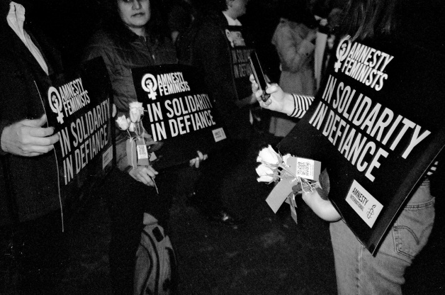

At our February meeting, Jessica Fortune and Ophelia Chidgeyfrom **Amnesty UK’s Feminist Network** spokeabout the work of the Network and their campaigning plans for this year, including the campaign to Rise with Afghan Women and plans for their event on 8 March to celebrate International Women’s Day and highlight the continuing struggles for gender equality and social justice. To be kept informed of and support their work, email [feministnetwork@amnesty.org.uk](mailto:feministnetwork@amnesty.org.uk) or check them out on their [blog](https://www.amnesty.org.uk/blogs/amnesty-feminist-network-blog),[Instagram](https://www.amnesty.org.uk/blogs/amnesty-feminist-network-blog), [LinkedIn](https://uk.linkedin.com/company/amnesty-feminists) and [YouTube](https://www.youtube.com/channel/UC7TMqYGGHCx6TbhS7pR7ntg).

**IRAN**

**Pakhshan Azizi and Verisheh Moradi, both women from Iran’s Kurdish minority, are at imminent risk of execution in Iran.** The Iranian authorities have intensified their use of the death penalty to instil fear, particularly targeting ethnic minorities like Kurds.

Pakhshan, a humanitarian aid worker, is being criminalised for helping women and children displaced by ISIS. Verisheh, a member of the group East Kurdistan Free Woman Society, is facing the death penalty following a grossly unfair trial. Since their arrests in August 2023, both have revealed being tortured, held in solitary confinement, and subjected to gender-based violence.

[Please sign the petition to the Iranian embassy](https://www.amnesty.org.uk/actions/stop-executions-pakhshan-azizi-verisheh-moradi?utm_content=159590&utm_campaign=MEMA6007S_ACT_IAR_DPEN_Pakshan%26Verisheh_5Mar&utm_medium=email&utm_source=amnestyuk) and demand that Iranian authorities stop these executions and release Pakhshan and Verisheh immediately.

**HONG KONG**

**2025 marks a critical year for human rights in Hong Kong**. It is the 5th anniversary of the [National Security Law](https://www.amnesty.org/en/latest/press-release/2021/06/hong-kong-national-security-law-has-created-a-human-rights-emergency/) imposed by the Chinese government, which decimated the city’s freedoms and resulted in an exodus of nearly half a million Hong Kong people, more than 150,000 of whom are now in the UK.

**Hong Kong people in the UK remain at risk due to transnational repression**. On Christmas Eve last year, [the Hong Kong Government issued new bounties on six exiled human rights defenders](https://www.amnesty.org.uk/press-releases/hong-kong-police-issue-absurd-cash-bounties-overseas-activists?utm_content=159438&utm_campaign=MCFR1425S_LG_MM_Feb_25&utm_medium=email&utm_source=amnestyuk), three of whom are in the UK. Currently, eight individuals in the UK are wanted by Hong Kong National Security Police. Recently, anonymous letters were sent to London residents offering a reward for information on the wanted persons.

**Last year, Amnesty published a report ‘**[**On My Campus, I Am Afraid**](https://www.amnesty.org/en/documents/asa17/8006/2024/en/)**’ highlighting repression of overseas students.** Last month, Amnestymade a submission on transnational repression to the Joint Committee of Human Rights in Parliament, whose findings will be published this summer, and willcontinue to press the government to act to protect exiled human rights defenders and diaspora communities. There will be an opportunity to support this campaigning ahead of the 5-year anniversary of the National Security Laws in June. **You can opt to be kept informed of developments** [**here**](https://www.amnesty.org.uk/actions/hong-kong-solidarity?utm_content=159438&utm_campaign=MCFR1425S_LG_MM_Feb_25&utm_medium=email&utm_source=amnestyuk) **or check out the Amnesty Hong Kong Programme webpage** [**here**](https://www.amnesty.org.uk/issues/human-rights-hong-kong?utm_content=159438&utm_campaign=MCFR1425S_LG_MM_Feb_25&utm_medium=email&utm_source=amnestyuk)**.**

**ANTI-RACISM**

**Last month, Amnesty UK issued** [**a new report Automated Racism**](https://www.amnesty.org.uk/predictive-policing)**, about the use of technology by UK police forces to attempt to “predict crime”.** “Crime prediction” is when police use automated technologies for policing. Amnesty calculates that almost three-quarters of UK police forces are using it. **Amnesty argues that these systems are, in effect, a modern method of racial profiling,** reinforcing racism and discrimination in policing, and that their use violates people’s rights.

**Amnesty is calling on the Minister for Policing, Fire and Crime Prevention to prohibit automated and ‘predictive’ policing systems in England and Wales. You can** [**sign the petition here**](https://www.amnesty.org.uk/actions/ban-predictive-policing).

**NIGERIA: SHELL AND THE NIGER DELTA**

King Okpabi of Ogale joining activists outside the court, holding bottles filled with polluted water from the Niger Delta.

Ten years ago, residents from the Bille and Ogale communities in Nigeria claimed that their livelihoods had been destroyed and homes damaged by hundreds of oil spills caused by Shell. The pollution caused widespread devastation to the local environment, killing fish and plant life, leaving thousands of people without access to clean drinking water. **The communities brought their claims in the UK courts, but Shell repeatedly delayed the case arguing that it had no legal responsibility for any of the pollution.** The delay has had a devastating effect on people’s lives.

Finally, after a decade-long fight for justice, the Preliminary Issues Trial of Nigerian Law for Shell vs Ogale and Bille communities **took place at the UK High Court from 13 February to 10 March**. The preliminary issues trial will determine the scope of the legal issues to be decided at the case’s full trial, set for late 2026. Although the case is being heard by a British judge in a UK court, it will apply Nigerian law.

Shell has obtained approval for the sale of its business in the Niger Delta, and therefore **it is more vital than ever that they are held accountable for polluting the environment and causing human rights abuses in the Niger Delta.** On 13 February, campaigners from Amnesty and other organisations and individuals gathered outside the court to put pressure on Shell to clean up their mess.

**Amnesty will be organising briefing meetings and actions** for us to get involved throughout 2025. See this [Guardian report](https://www.theguardian.com/world/2025/mar/07/nigerian-king-faces-shell-london-high-court-decades-oil-spills) for more information about the case.

**PROTECT THE PROTEST**

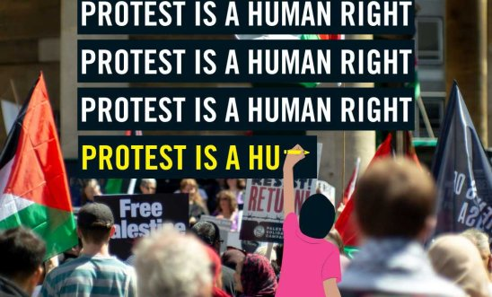

**The government’s Crime and Policing Bill received its Second Reading in the House of Commons on 10 March**. This is the fourth anti-protest bill presented to Parliament in as many years. The Bill seeks to criminalise yet more parts of peaceful protest, including banning face coverings, and gives police the power to force people who are on limited visas to leave the country.

The bill covers a diverse range of issues, but **its clauses on protest are especially problematic**. These measures are taken from last year’s Criminal Justice Bill, which was part of the previous Government’s far-reaching crackdown on peaceful protest. Protesters continue to face mounting criminalisation for peaceful protest as well as the imprisonment of peaceful protesters for longer than some serious violent offenders.

More information [here](https://www.amnesty.org.uk/press-releases/uk-alarming-crime-and-policing-bill-yet-another-assault-right-peacefully-protest).

**ECONOMIC, SOCIAL AND CULTURAL RIGHTS**

[Amnesty has made a submission](https://www.amnesty.org/en/documents/eur45/8912/2025/en/?utm_source=LINKEDIN_COMPANY-United+Kingdom&utm_medium=social&utm_content=16048607088&utm_campaign=Amnesty&utm_term=-) to the UN Committee on Economic, Social and Cultural Rights regarding the UK’s compliance with the International Covenant on Economic, Social and Cultural Rights. In the submission, **Amnesty lists a series of areas where the UK is failing to meet its obligations under the Covenant, including non-discrimination, social security, housing and health.**  Last month, Amnesty joined activists from Growing Rights Instead of Poverty Partnership (GRIPP) at the UN to call for urgent action.

**AMNESTY UK NATIONAL CONFERENCE AND AGM 2025**

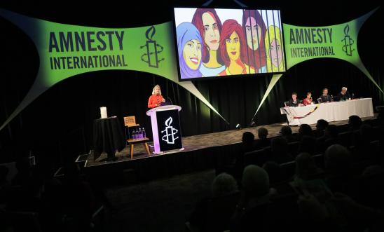

**This will take place on 5-6 July 2025 at the University of Warwick.** The weekend is designed to offer participants an opportunity to celebrate Amnesty’s powerful movement, connect with fellow activists and supporters, take part in Amnesty UK decision-making and plan for the year ahead.

The Conference will feature a range of workshops, panel sessions and networking opportunities. Further details will be provided in forthcoming newsletters. Formal notice of the AGM will be sent to members in mid-May.



**Tuesday 18 March at 7:30pm to 8:30pm. Kent Network online speaker meeting about the International Criminal Court. Email** [**arianna.pisetti@amnesty.org.uk**](mailto:arianna.pisetti@amnesty.org.uk) **for a link.**

**Wednesday 2 April at 1:00pm to 3:00pm Monthly Guantanamo Vigil at Parliament Square, London. All welcome. Email** [**Mark.clixby@amnesty.org.uk**](mailto:Mark.clixby@amnesty.org.uk) **for more details.**

**Saturday 5 April at 1:00pm to 4:00pm: South East Regional Meeting at Bramble Hall, Balcombe, Haywards Heath, RH17 6HR. Email** [**arianna.pisetti@amnesty.org.uk**](mailto:arianna.pisetti@amnesty.org.uk) **for details.**

**Sunday 6 April at 10:30am: Medway Team in person gathering. All welcome. Email** [**charlotte.gemmell@hotmail.co.uk**](mailto:charlotte.gemmell@hotmail.co.uk) **for venue details.**

**Monday 7 April at 7:30pm. Maidstone, Medway and Swale Group meeting at Maidstone Community Support Centre****, 39-48 Marsham Street, Maidstone, ME14 1HH. Email** [**mmands.amnestygroup@gmail.com**](mailto:mmands.amnestygroup@gmail.com) **for details.**

**Tuesday 15 April at 7:30pm to 8:30pm. Kent Network online speaker meeting: Israel and the Occupied Palestinian Territories. Details to follow.**

**Saturday 5 July to Sunday 6 July. Amnesty UK National Conference and AGM at Warwick University.** [**More information here**](https://www.amnesty.org.uk/annual-general-meeting?utm_content=159832&utm_campaign=MEMA6011S_Amplify_Summit_Members&utm_medium=email&utm_source=amnestyuk)**.**

All the best

Graham