KENT NETWORK UPDATE: DECEMBER 2024

Dear all

We do not normally send a newsletter in December, but here are a few updates, with two pieces of **good news**, a reminder of the **work that still lies ahead** and the dates and venue of next year’s **national conference and AGM**. It is also an opportunity to send you **our very best wishes** for the current festive season and for the year to come.

GOOD NEWS 1: REFUGEES



[The Home Office has announced that newly recognised refugees will be given 56 days to find a place to live, which is almost double the current 28-day period.](https://www.refugeecouncil.org.uk/latest/news/refugee-council-welcomes-change-to-the-move-on-period-for-refugees/#:~:text=The%20Home%20Office%20has%20announced,had%20been%20granted%20refugee%20status.)  Known as the "move-on" period, the previous 28-day deadline put refugees at high risk of homelessness and destitution, at the very moment the Government had granted them safety.  The change should help people who have been given refugee status to have enough time to find accommodation, work and other necessities to rebuild their lives in Britain.

GOOD NEWS 2: TOOMAJ SALEHI RELEASED

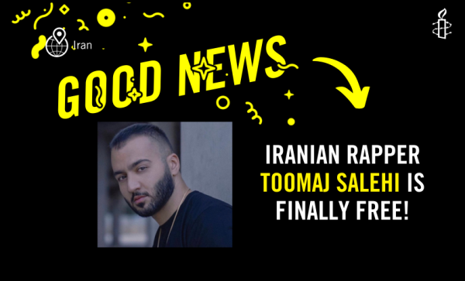

[Toomaj Salehi, the Iranian rapper, activist, and advocate for justice, who featured in two of our newsletters this year, has finally been released](https://www.bbc.co.uk/news/articles/cx269dr42vko). Through his music, Toomaj called for justice, equality, and an end to the violent crackdown on protests in Iran. His release is proof that when we unite for what’s right, we can create change. Thank you to all those who responded to Amnesty’s call for action.

GENOCIDE IN GAZA

Amnesty has published a report that documents **sufficient basis to conclude that Israel has committed, and is continuing to commit, genocide against Palestinians in the occupied Gaza Strip**. The report, [***‘You Feel Like You Are Subhuman’: Israel’s Genocide Against Palestinians in Gaza***](https://www.amnesty.org/en/documents/mde15/8668/2024/en/), documents how, during its military offensive launched in the wake of the deadly Hamas-led attacks in southern Israel on 7 October 2023, Israel has unleashed hell and destruction on Palestinians in Gaza brazenly, continuously and with total impunity.

NATIONAL CONFERENCE AND AGM: UNIVERSITY OF BIRMINGHAM 5-6 JULY 2025

**This will be the first in-person combined National Conference and AGM since Covid**. The event will be open to AIUK Section members and activists only. It will not be a public event, but rather a gathering space for the AIUK movement. The event will incorporate both important AIUK governance and additional sessions designed to entertain, upskill, and spark conversation. I always found the joint annual conference and AGM a hugely enjoyable and motivating moment in the AI annual calendar. The event has been sorely missed by activists since the practice was interrupted. While some of the proceedings will be streamed online, I hope some of you will be able to find the time to attend in person. If so, I shall look forward to seeing you there.