Next Meeting
Thame Amnesty AGM
Wednesday 25th April, 7.30 p.m.
Sports Centre
Lord Williams Lower School

In addition to the usual business and election of officers we will be using the opportunity to contribute to Amnesty’s Big Debate.

We welcome all contributions and would want to hear from the wider membership so please join our discussions on this occasion

If anyone would like to put themselves forward for any of the current officer posts of Chair, Vice-Chair, Treasurer or Secretary – please contact Bob before the evening of the meeting

Everyone welcome – so please come along
Contact Bob for further details -
christinefieldsend@hotmail.com

March Meeting
At this month’s meeting we had review of upcoming events and discussions in relation to organisation, content and forthcoming speakers. Owen also provided information for those participating in the ‘Your Help Needed’ telephone campaign which we will undertake over the next month – details in the last newsletter
Amongst the actions that we undertook this month were individual letters to the Saudi Ambassador in relation to women’s rights in Saudi Arabia (see March newsletter for details). A group letter was sent to the Iranian authorities regarding Habibollah Golparipour a Kurdish minority political prisoner who is at risk of execution following the rejection of his appeal against the death penalty. A petition to Dutch Shell calling for a comprehensive clean up of the oil pollution in the Niger delta was also signed. We are also writing to our local MP John Howells in relation to Filep Karma (West Iran) asking him to raise this matter with William Hague. For further details of any of these actions please contact Bob on christinefieldsend@hotmail.com
We also had discussions in relation to the prison camps in North Korea thought to contain 200,000 people. The deadline for active involvement with the petition was 23rd March, but Amnesty International are still seeking donations to support the campaign further details on the Amnesty web-site.
Our thanks also goes to Sue for all her hard work in setting up the Local Thame Amnesty web-site and getting all our technology up to date. Have a look at our new resources and let us have your feedback:-

New webpage: http://www2.amnesty.org.uk/groups/thame

Yahoo group:
http://groups.yahoo.com/group/thame-amnesty/

Facebook page:
http://www.facebook.com/ThameAmnesty
You can contact Sue directly on suer1953@yahoo.co.uk

Dates For Your Diary

18th – 20th May – Flower Festival,
St Mary’s Church, Thame

Volunteers needed to help with our display

June Meeting – 27th June

Michael Esvelt the Amnesty trainer from Oxford City will run the seminar on the ‘Control Arms’ campaign – an opportunity to find out more about this topical issues and Amnesty’s role

Saturday July 14th – Street Collection

The Thame Amnesty street collection will be held Saturday July 14th – collectors and volunteers needed – contact Owen on
davies2399@yahoo.co.uk or
(01844 214466)


Amnesty International UK National Conference& AGM
The Bullet Proof Conference 2012
13th – 15th April 2012 - Manchester
Join activists, staff and guests at what promises to be a truly inspirational event. This year’s conference will focus on 2012’s once-in-a-lifetime chance to forge a robust, bulletproof Arms Trade Treaty. We’ll be joined by a Human Rights Defender affected by the arms trade, a member of the UK Arms Trade Treaty negotiating team and Amnesty’s Arms Campaign Director for a thought provoking debate, chaired by The Times’ Defence Editor Deborah Haynes.
Oxford Amnesty Group are undertaking a sponsored ‘triathlon’ to travel to this event – Sue is also attending the conference on our behalf but if you would like to sponsor the Oxford group the link is
http://www.justgiving.com/AmnestyAlternativeTriathlon
In addition to practical workshops, debates and decision-making, we’ll be taking over Manchester City Centre with a campaign action and giving you the opportunity to party on the Saturday Night with fellow activists in a very unusual location.

AIUK is able to offer concessionary places to groups who are unable to pay the full price. However we only have a limited number. Please note that there will be one concessionary place per group. If you would like to apply for a concessionary place please email amnesty@blueprintpartners.com
informing them that you are a group member. Please discuss this with your group first.
For further information - www.amnesty.org.uk/agm
Alternatively call Lucy Lyall on 0207 033 1686.
Booking deadline: 2 March 2012

Actions

AI Death Penalty
As today’s figures show, we are moving slowly but surely towards a death penalty-free world. Only twenty countries carried out executions last year, down from twenty three in 2010. Sadly, some of the countries which do execute are executing more people, especially Iran, Iraq and Saudi Arabia. 676 people were executed around the world last year – plus the thousands more thought to have been executed in China.
Behind these figures are the individuals, like Behnoud Shojaee – and Troy Davis. The fight against Troy’s death sentence ended one crushing night last September, doubts over his guilt still unresolved. He was one of 43 people executed in the USA last year.
At Amnesty we believe any execution is one too many. There is never any justification for the use of the death penalty. So please help us spread the word today.
For a full copy of the report
http://www.amnesty.org.uk/news_details.asp?NewsID=20017&utm_source=Email&utm_medium=mass_email&utm_campaign=DP&utm_content=report2012_link1

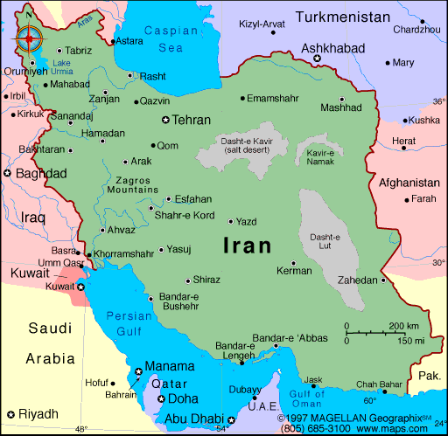

Mohammad Mostafaei was 14 when he witnessed his first public execution in Iran - and it changed his life. Shocked by the sight of a scared young man being executed, he trained as a lawyer. Since then, he has devoted his life to defending those facing the death penalty, taking on cases no others would – such as Sakineh Mohammadi Ashtiani, who was sentenced to death by stoning for adultery. One day he was told about the case of Behnoud Shojaee, who was just 17 when he killed another boy in a fight. Behnoud turned himself in and was sentenced to death. Iran is almost alone in sentencing and executing under 18s: in doing so it violates international law. Take action
http://amnesty.org.uk/content.asp?CategoryID=78&utm_source=Email&utm_medium=mass_email&utm_campaign=DP&utm_content=behnoud_link2

Chair – Bob Fieldsend, Vice-Chair – Anita Clayton, Treasurer – Owen Davies, Press & Publicity – Jeannette Watson & Newsletter/Secretary – Julia Worms

